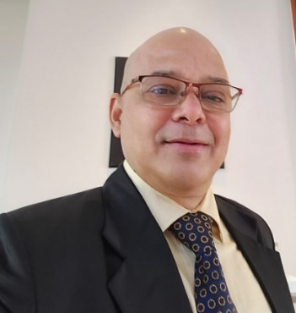
Sanjay Goel
Learning Consultant and Facilitator, Mumbai

Summary
Rich and varied experience of more than three decades in Learning and Development, Behavioural and Soft Skill Training, Leadership Development, Coaching and Counselling, NLP and Hypnosis Practice, Consulting, Team Management, Sales and Consultative Selling.

More than 1000 days of classroom training, 300 online training sessions and 500 one-to-one counselling and coaching sessions, 300 days of leadership training

Industry Experience
- 18 years of experience in training/ facilitation
- FranklinCovey – Workshops on 7Habits of Highly Effective People, Time Management and Situational Leadership
- Par Excellence – Workshops on Emotional Intelligence, by MHS EQi2.0
- Privi Group – 8 years of experience as training lead, managing entire learning cycle for HO and Factory, Privi Speciality Chemicals, Privi Life Sciences and Privi Biotechnology divisions. (still delivers workshop for them as a consultant)
- Participated in Human Process Lab by Indian Society of Applied behavioral Science (ISAB)
- Landmark Forum Graduate

Major Certifications
- Globally Certified BELBIN and DiSC Assessor and Trainer
- Certified Coach and Therapist by ICHARS
- Certified NLP and Hypnosis Practitioner by ICHARS

Expertise
- Design and deliver customized soft skills, behavioral and leadership trainings
- Outbound team building workshops (experiential learning sessions)
- Supervisory, managerial and leadership development workshops
- Coaching and counselling

Professional Qualification
- MBA in Human Resource Management
- Graduation in Physics

Contact:
Mobile +91 9820 457355, email: sanjaybgoel@gmail.com

About Sanjay Goel (key highlights)
- Based out of Mumbai, with more than 18 years in learning domain;

- Expertise in soft skills, behavioural, communication and leadership trainer

- Experience in designing and delivering customized workshops specific to the business needs.

- Experience in conducting experiential learning session using fun games and activities. Conducted multiple outbound teambuilding sessions

- 8 years hands on experience in L&D, managed entire learning cycle from TNI to effectiveness evaluation

- Conducted multiple sessions on mental health and stress management

- Experience of converting content from management books into training sessions

- Certified Coach, Hypnosis and NLP Practitioner

- Globally certified trainer and assessor of DiSC and Everything DiSC by John Wiley & Sons

- Globally certified BELBIN assessor and trainer

- Experienced in delivering both classroom and online sessions using zoom, google meet, Webex and MS Teams.

- Certified trainer of 7Habits of Highly effective People, Situational Leadership, Emotional Intelligence and Art of Coaching.

- Delivered multiple batches Six-day Leadership, Managerial and Supervisory Development workshop (two day every month) along with coaching and assignments

- Hands-on experience in leadership and team handling

- Has rich sales and marketing experience of over 17 years, trained sales teams in consultative selling. Worked with reputed organizations like FranklinCovey, Neuroleadership Group, Grindwell Norton Ltd., Introductions to name the few.

- Experienced in delivering workshop in varied industries, worked with reputed organizations like Accenture, Amaron, BPCL, CISCO, Credit Saison, DP World, Deloitte, DXC Technologies, Epiroc, Flipkart, GEP, Heromotor corp, HPCL, IVP, Jindal Steel Works, Kotak Mahindra Bank, L&T, NTPC, Oracle, SBI, Schaeffler India, Sharekhan, Tata Capitals, Tata -Chemicals, TCS, USV Limited, US Consulate to name a few.

