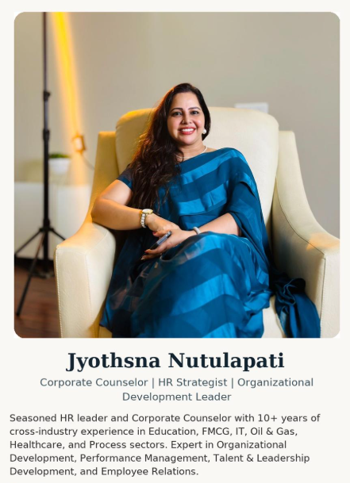
📧 jyosri0789@gmail.com | 📞 +91 9652614689/ 6304439190
🔗 LinkedIn: www.linkedin.com/in/jyothsna-nutulapati-406b4b118
STRATEGIC HR PARTNER | PEOPLE & CULTURE LEADER
Infrastructure | Energy | Healthcare | Project-Based Industries | IT | Retail | FMCG
PROFESSIONAL SUMMARY
Strategic HR leader with over a decade of experience shaping people strategies across high-impact sectors including infrastructure, energy, healthcare, and manufacturing. Proven ability to translate business priorities into scalable HR frameworks that drive performance, culture, compliance, and employee experience. Expert in designing and executing enterprise-wide systems for EVP, culture-building, HR tech transformation, competency modeling, and leadership development. Adept at managing HR operations across geographically distributed sites with a focus on agility, analytics, and outcomes.

STRATEGIC HR EXPERTISE
• Strategic HR Planning & Execution
• Culture Building as a Business Driver
• Talent Management & Succession Planning
• Learning & Development Architecture
• PMS, Competency Modeling, Profiling & Mapping
• Employee Engagement & Experience Programs
• Total Rewards System Design
• Leadership Development & Assessment Centers
• HR Technology Implementation (KEKA, HROne)
• HR Analytics & Dashboards
• Policy Design, Deployment & Process Governance
• ISO Standards, Compliance & Statutory Audits
• Multi-Site/Project HR Leadership (North, South, East, West)
KEY CAREER ACHIEVEMENTS
Focalcxm – HR Manager (Nov 2024 – April 2025)
• Spearheading strategic HR initiatives to align people strategies with business goals
• Driving high-impact engagement frameworks to enhance employee experience
• Leading initiatives in policy enhancement, performance management, and culture evolution

AMPS – US Healthcare - HRBP (August 2023 to June 2024)
- Accomplished the challenge of Work from home policy to Work from office
- Designed Learning and Growth policies and calendar for the year
- Performance management system for the financial year
- Leave management system implementation
- Employee engagement and Employee relations management
- Entire onboarding to Exit process for 8 Departments (140 employees)
- Policy enhancements and Creation on versions
- Marketing and Branding , company promotional activities
- KEKA tool used for effective and smooth working on LMS, L&D, PMS, Payroll etc.
Makeen Energy – Pan-India Plant HR Coordinator (Sep 2022 – Apr 2023)
• Implemented HROne PMS across all locations within one month
• Rolled out ISO-aligned audit frameworks and L&D calendars for 21 plant HRs
• Built centralized HR analytics and reporting mechanisms
• Launched engagement programs anchored on EVP and growth visibility
Mahathi Infra Services Pvt. Ltd. – Strategic HR Business Partner (Sep 2020 – Sep 2022)
• Developed a unique Competency Dictionary and implemented job-role mapping
• Designed and executed a Performance Management System tailored to infra projects
• Institutionalized company-wide Employee Reference Policy and HR SOPs
• Delivered the full employee lifecycle across project deployment zones, ensuring compliance, scalability, and retention

Asian Technology Solutions - APAC & Domestic HR & L&D (March 2017 to Feb 2020)
- Set up HR processes and Support HR services for Indonesia, Malaysia branches.
- Prepare JDs for offline & online marketing, Sales dept, tech support, CRM teams.
- Recruit, Lead, teach, evaluate performance of new trainers and Career advisors.
- Coordinating with the trainers and students and ensuring timely completion of the batches and courses as prescribed.
- Performance Improvement Plan (PIP) tracking for low performing employees.
- Conduct seminars & workshops to improve branding along with social media communication
- Develop Course curriculum for all the upcoming courses
- Employee Engagement activities for trainers, students, colleges, clients to develop highly engaged, collaborative and vibrant teams
- Prepare and deliver training related to soft skills.
- Mar.Comm (Marketing & Communication) & branding activities.
- Assisting/ guiding the Digital Marketing & Offline marketing team with reference to the content of the courses and branding activities.
- MIS Reports: Responsible for data maintenance, preparation and circulation of various HR reports like Hiring Cost data, Headcount reconciliation, New Offers & New Joiner report, Recruitment Sources data, Department wise Cost tracking, Recruitment analysis etc.

HR Consultant – Project-Based Advisory Roles (2024)
• Provided HR consulting to Sannverse Railtech & Infra Pvt. Ltd.(TA,L&D & PMS) ,Makonis (IT Staffing & Solution), Tecdatum (Marketing & Branding)
• Designed HR operating models, compliance frameworks, and culture-anchored engagement strategies
• Initiated leadership development frameworks and profiling models aligned to business growth

Freelance Projects
- Dabur (Hyderabad) – Internship Program on Recruitment life cycle. (1 month)
- ATS (Hyderabad)– Event manager, Communication & Soft skills Trainer. (6 months)
- Margadarshi Chit funds (Hyderabad) – Soft skills Training for Sales Department on Customer interaction and retention. (1 month)
- Big Bazaar (Hyderabad) – Retail staff on behavior sills and customer interaction. (3 months)
- Finance careers (Pvt Institution- Hyderabad) – Soft skills and interview skills. (3 months)
- Global Technologies (Auto Cad Institute- Hyderabad) – IELTS, GRE verbal (6 months)
- Veta English speaking Institute (Chennai) – IELTS, Functional English (6 months)
Extra-curricular summary
- Captain of Nationals Hockey at the Zonal Level and won the Bronze medal in Hockey Team.
- Captain of the winning team in the Sr. Hockey tournament at the Regional level.
- Captain of the winning team in Jr. Throw Ball tournament at Zonal Level.
- Captain of the team that stood first in the 400 mtr Relay Race (seniors).
- Active member of Chinmaya mission youth association.
- Trained classical Bharatnatyam Dancer.
- Trained Carnatic vocal music.
- Theatre Artist.
Hobbies
- Enthusiastic nature lover – Gardening.
- Love connecting with people – social media, Surfing.
- Feel good with interior designing and decoration.
- Innovative and creative armature fashion designer.
- Love conducting and organizing events.
EDUCATION – PhD Scholar (SR University Warangal – DEI&B AI Era)
- MBA – Human Resource Management, Osmania University
- M.Sc. – Psychology (Industrial & Organizational Behavior)
- M.A. – English Literature, GITM University
CERTIFICATIONS & HR TECHNICAL TOOLS
• HROne, KEKA, Greythr – HRMS, PMS, LMS Implementation
• Psychometric Assessments & OB Diagnostics
• HR Analytics Dashboards & Strategic KPIs
• Competency Framework Design & Mapping Tools
LANGUAGES
English | Hindi | Telugu | Tamil | Kannada

