Meiyappan Rajamanickam
myeyeopen@gmail.com
Chennai 600 102 +91 72999 26310

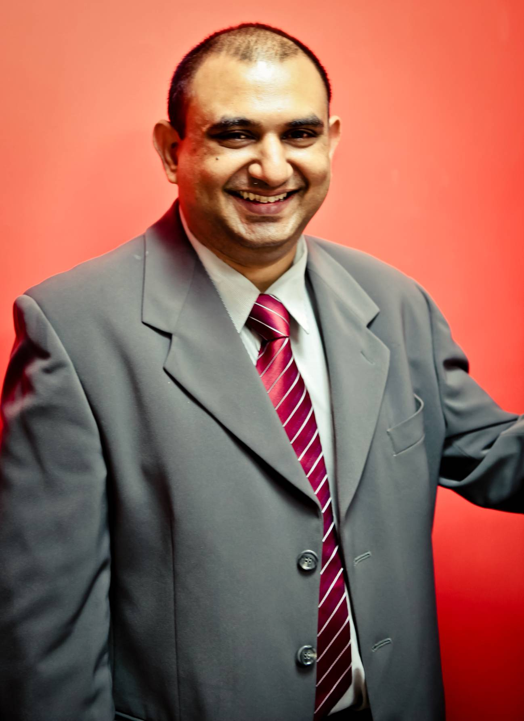

OBJECTIVE

I seek challenging assignments to reach new levels of proficiency in my technical, teaching, and mentorship skills.

TECHNICAL EXPERTISE SUMMARY
I began my career in mainframe application development in the year 1997. Since then my professional career has included application development as well as training primarily in the IBM Mainframe computing platform.

TECHNICAL SKILLS

Hardware : ES/9000, IBM 3090, Z800 series and PENTIUM m/c’s
Operating
Systems : MVS/ESA, Z/OS, DOS, Windows, OS/2 WARP 4, UNIX, Linux, AIX
Languages : COBOL, VS COBOL II, MF COBOL, C, C++, Java, Assembler
DBMS : DB2 (Mainframe), DB2 UDB (Linux, Unix and Windows), MySql
Software : CICS, TSO/ISPF, CLIST, REXX, Roscoe, NETEXPRESS, File Aid, VSAM, QMF, Platinum, SPUFI, Xpeditor, Endevor, CA-Intertest, Cool:GEN, BPWin, ERWIN
Y2K tools : VANTAGE 2000 (MDI), SEEC COBOL ANALYST 2000

Present Occupation:

I offer my services as a corporate trainer specializing in the area of Application Development programming in the IBM Mainframe Platform. My corporate training client list includes:

- Wells Fargo
- IBM
- HSBC
- Mphasis
- Wipro
- BNP Paribas
- Hewitt Associates
- CSC (Computer Sciences Corporation)
- Hexaware Technologies
- L&T Infotech
- Datamatics Global Services
- ATOS Syntel
- NTT Data
- DXC

A typical Mainframe Application course varies is duration from 20 to 40 days and is an intensive full day train program that includes project work or case studies and the modules covered are:
- MVS OS concepts
- TSO/ISPF
- JCL
- VSAM
- COBOL
- CICS
- DB2

Apart from the above modules, I’ve also conducted training programs on:
- MF COBOL (on Unix based and Windows based environments) products like Net Express, Server Express and Mainframe Express
- SUN MTP – a CICS replacement product for the UNIX AIX Environment
- Advanced SQL training on DB2 UDB on Windows ( the LUW version for Linux , Unix and Windows)
- CLIST and REXX on the mainframe
- Assembler

PROFESSIONAL EXPERIENCE SUMMARY

Start Date : July 2004

Company : SOFIL Information Systems Pvt Ltd

Role : Contract Programmer

Project : Pension estimation/calculation system for the Japanese Government. Project title – KGCS (Kumiyayin Genkyo Chosa System) for MHTS (Mizu Ho Trust Systems).

Technical Environment: MF_Cobol, Windows 2000, SQL Server

Start Date : Sep 2003

Company : Florida Software Solutions, Chennai

Role : Senior Technical faculty, IBM Mainframe Training Program

Courses taught : Introduction to MVS, JCL/VSAM, COBOL, CICS, DB2 for
the application programmer

Corporate Training: Conducted a four week corporate training program for
employees of Wipro, Pune at their site. Conducted shorter
term programes for the Chennai and Bangalore Wipro staff.

Start date : May 2001

Client : NorthWest Airlines

Company : Stingray Technologies

Technical
Environment : IBM Mainframe, MVS, TSO/ISPF, JCL, DB2, CICS,
Windows NT, DB2 UDB, CoolGEN, Java

Project(s) : WorldPerks, BizPerks and eBizPerks programs (NWA
member loyalty programs)

Role : Senior Programmer Analyst, Offshore Co-ordinator

Additionally : Designed and wrote the user manual for the ‘BizPerks’
Product at Stingray Technologies

PROFESSIONAL EXPERIENCE SUMMARY (continued…)

Start Date : May 2000

Client : CalWIN - Welfare System Project for the State of California

Company : United Technical Consulting Firm

Technical
Environment : Windows NT, UNIX, ORACLE, TUXEDO,
COBOL, C, Power Builder

Project : CalWIN – System development

Role : Consultant Programmer Analsyst;
Facilitated JRP (Joint Requirements Planning) and
JAD (Joint Application Development) sessions

Start Date : Feb 2000

Client : FCSO – First Coast Service Options (Subsidiary of
Blue Cross Blue Shield, Fl)

Company : United Technical Consulting Firm

Technical
Environment : IBM OS/390, MVS, TSO, DB2, SPUFI, QMF,
WINDOWS NT, NETEXPRESS, *SQL

Project : BDP (Beneficiary Database Prototype) System

Role : Programmer Analyst; (COBOL, DB2)

Start Date : Aug 1999

Client : Rexnord Thomas Couplings

Company : Computer Enterprises Inc.

Technical
Environment : IBM ES/9000, MVS, Roscoe, COBOL 390, JCL,
VSAM, SUPRA, CICS, ca-Intertest

Project : Die Tracking System Automation

Role : Programmer Analyst; (COBOL, CICS, SUPRA)

PROFESSIONAL EXPERIENCE SUMMARY (continued…)

Start Date : September 1997

Client : Safety-Kleen

Company : Computer Enterprises Inc.

Technical
Environment : IBM ES/9000, MVS, COBOL II, VSAM, DB2,
Roscoe, File Aid, Platinum, SPUFI, Xpeditor

Project : BAP (Branch Automation Project) PHASE III

Role : Programmer Analyst; (COBOL, VSAM, DB2,
ROSCOE)

Start Date : Jan 1997

Client : Westvaco

Company : SquareD

Technical
Environment : IBM 3090, VS COBOL II, JCL, CICS, PL/I, and
VSAM

Project : Year 2000 Conversion

Role : Programmer Analyst

