Aruna Mary Morenas

Contact No:9952912044

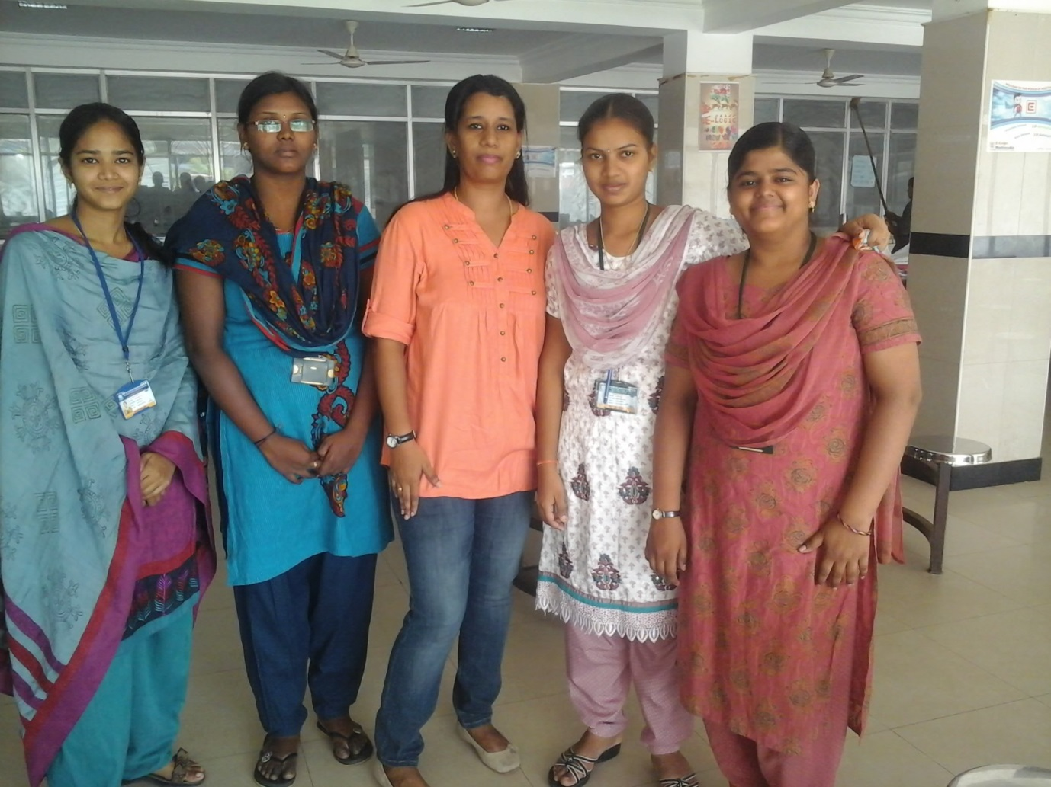

**Career Objective:**

To manage a Training team that helps employees deliver consistent performance in the shortest possible time by deploying an effective training framework.

**Synopsis:**

I am a training professional who has hands-on experience in the following areas:

* Soft skills / Behavioural training
* Language and communication training (written and spoken)
* Analytical thinking
* Attention to detail
* Result orientation
* Business communication (telephone and email etiquette)
* Team skills
* Customer management skills
* Listening skills
* Interview skills
* Group Discussion
* Culture (UK)
* Managing important training metrics.
* Basic Excel training
* Experience in teaching life science (Anatomy,Physiology,Microbiology & Genetics)

**Educational Qualification:**

**Pursuing Diploma in Training and Development**

Indian Society of Training and Development, New Delhi.

2014 – 2015

**Pursuing II year Masters of Science in Education Management**

Alagappa University

**Bachelor In Education (Science & English)**

IGNOU

2005-2007

**Master of Philosophy (Microbiology& Aquaculture)**

Vinayaga Mission Research Foundation

2007– 2008

**Master of Science (Zoology)**

QMGC, Madras University

2001-2003

**Bachelor of Science (Zoology)**

QMGC,( Madras University

1998 –2001

**Higher Secondary School Leaving Certificate (Class 12)**

Bentick Higher Secondary School

1996-1998

**Matriculation School Leaving Certificate (Class 10)**

St. Michael’s Matriculation School

1996

**Work Experience:TRAINING**

**Tata Consultancy Services, Chennai**

ILP-Freelance Trainer(BPO – Learning & Development) (March 2012– Till Date)

* SPOC for ILP freelance trainers in Chennai
* Conduct Training on behavioral and technical skills for freshers in different locations in TCS offices in Chennai and colleges in Tamilnadu.
* Evaluation of Trainees performance

**Success Mantra, Chennai**

Hindu College

Spoken communication (June 2013 to sep 2013)

**Vista Mind, Chennai**

SRM Engineering College, Meenakshi Engineering College

Placement Training

* Interview skills
* E.mail
* Group discussion
* verbal aptitude
* Presentation skill
* stress management

**Ace Panacea, Chennai**

SDNB Vaishnav college

Conversational skill (Spoken English)

**De’arc Learning Solutions, Salem**

Kailash Group of colleges, KIOT

Placement Training

**TEACHING AND ADMINISTRATION**

**Sushwani Matha Jain Vidyala School, Chennai**

School Principal (June 2011 – Feb 2012)

* Managed a team of 32 teachers and administered an headcount of 750 students.
* Scheduled timetable for teachers and students for the academic year.
* Organised the school Annual Day, Sports Day and other programs.
* Organised a medical camp for all students.
* Maintaining School Records & Registers as per CBSE board
* Evaluating teachers’ performance.
* Recruiting and training new teachers.

**Good Shepherd Matriculation Higher Secondary School, Chennai**

Higher Secondary – Teacher(Biology) (August 2010 – Feb 2011)

* Taught Higher Secondary students(Class XI & XII)
* Conducted practical exams as a part of the curriculum.

**The Vellamal International School, Chennai**

Higher Secondary Teacher – Biology (May 2009 – April 2010)

* Given 100% result in X & XII board exams.

**St. Thomas Matriculation Higher secondary School**

Higher Secondary Teacher – Biology (May 2008 – April 2009)

* Given 100% result in X & XII board exams.

**Radhakrishnan Matriculation School**

High School Teacher – Biology (May 2004 – April 2006)

* Given 100% result in X board exams.

**DonBosco Matriculation School**

High School Teacher – Biology (May 2003 – April 2004)

* Given 100% result in X board exams

**Awards and Achievements:**

* Best Teacher Award for 100% results in Radhakrishnan Matriculation School.

**Technical Skills:**

* Certification in Advanced Excel – NIIT

Nov 2012 – Jan 2012

* Diploma In Computer Applications

Feb 2008 – Apr 2008

**References:**

01. Sabitha(Contact No.9500060453)

Initial Learning Program(ILP) Lead – L & D

TCS-Velachery,Chennai

02. Kenneth(Contact No.9281057323)

Manager(HR) – Talent Engagement Group

TCS-Spencers, Chennai

**Personal Information:**

Date of Birth : 04 /12/1980

Gender : Female

Marital Status: Married

Caste : Anglo-Indian

Languages Known: English & Tamil

Permanent Address: No.34 Venkateswara Colony

4th Street,Madhavaram MilkColony

Chennai – 600 051.

Email: **marymorenas@rediffmail.com**

**Declaration:**

I hereby declare that the above Information provided by me is true and correct to the best of my knowledge.

**Date:**22.09.14 **Signature**